**Ex 19: Exercise: Dynamic Styles**

Your task is to **dynamically** apply a style (color: red) to the <p>Style me</p> element in the provided React app.

The style should be applied as an **inline style** (i.e., via the style attribute / prop) when the <button> is clicked for the first time. Once the button is clicked again, the styling should switch back to color: white, which should also be the initial style.

Make sure that the button toggles between these two styles (color: white <=> color: red).

Here's how the finished app should look like BEFORE the button was clicked:

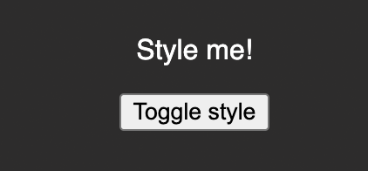

Here's how it should look like AFTER the button was clicked:

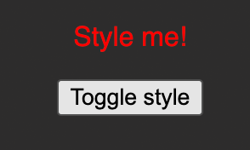

And here's how it should look like when the button was clicked again:



Important: Use React.useState() instead of just useState() as the latter can cause problems in this Udemy code environment.